Glance

Python/CLI APIs Horizon

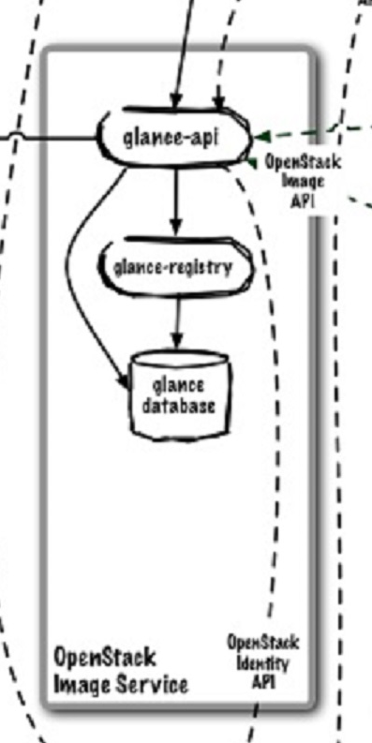

Swift Proxy nova-api nova-compute

Identity (Keystone)

**Glance** - provides a catalog service for storing and querying virtual disk images. Glance has been designed to be a standalone service for those needing to organize large sets of virtual disk images. However, when used along with Nova and Swift, it provides an end-to-end solution for cloud disk image management.

**glance-api** – accepts API calls

glance-api listens on port 9292

**glance-registry** – stores and retrieves metadata about images

**image-store** – image blobs stored here, swift or some other location – not actually part of glance, but glance needs an image store.

How does Nova interact with glance?